Date: 11 September 2016
Time: 12:00pm
Venue: Zone C, Tai Po Mega Mall

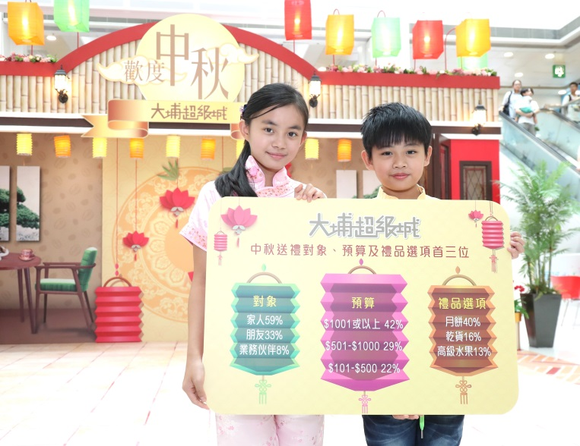

Headline
P.16 – 1/4
12 Sep, 2016
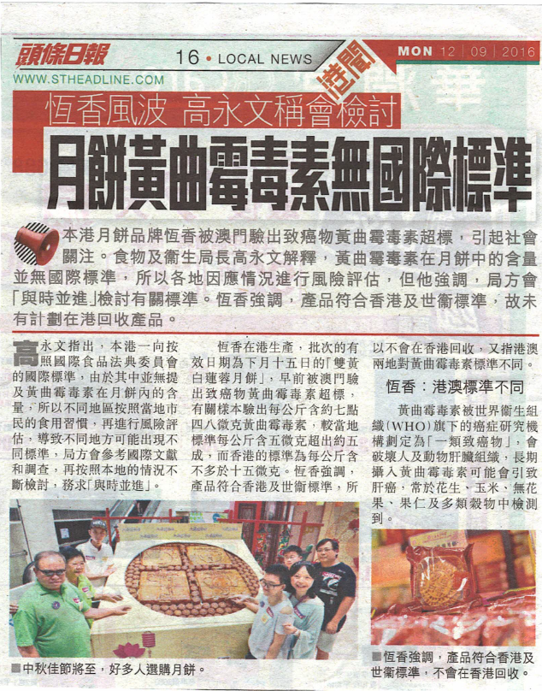

Oriental Daily
C9 – 1/8
12 Sep, 2016

Apple Daily
C7 – 1/18
12 Sep, 2016
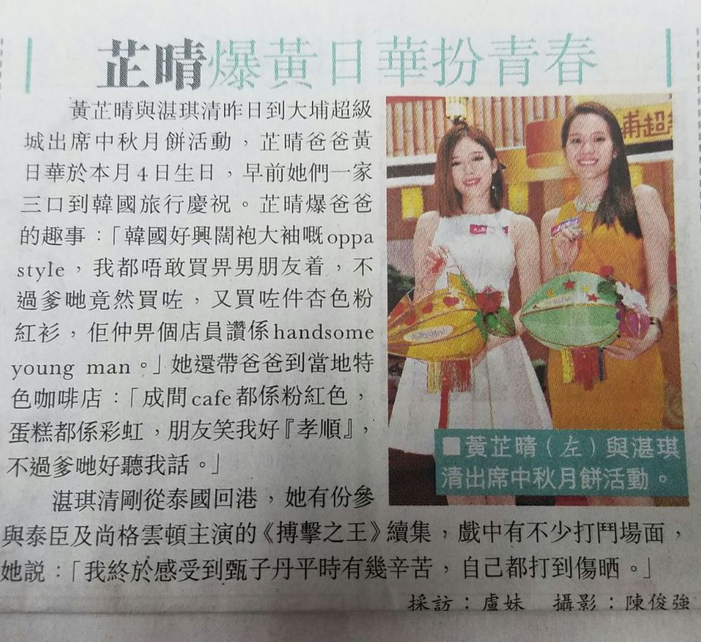

Sing Tao
D5 – 1/18
12 Sep, 2016
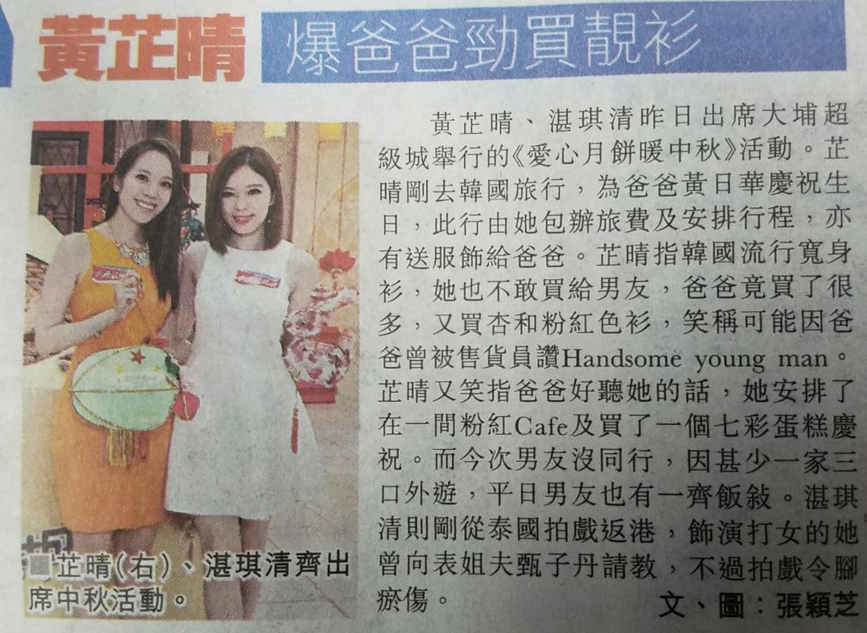

Headline
11 Sep, 2016
http://hd.stheadline.com/news/realtime/ent/1094769/
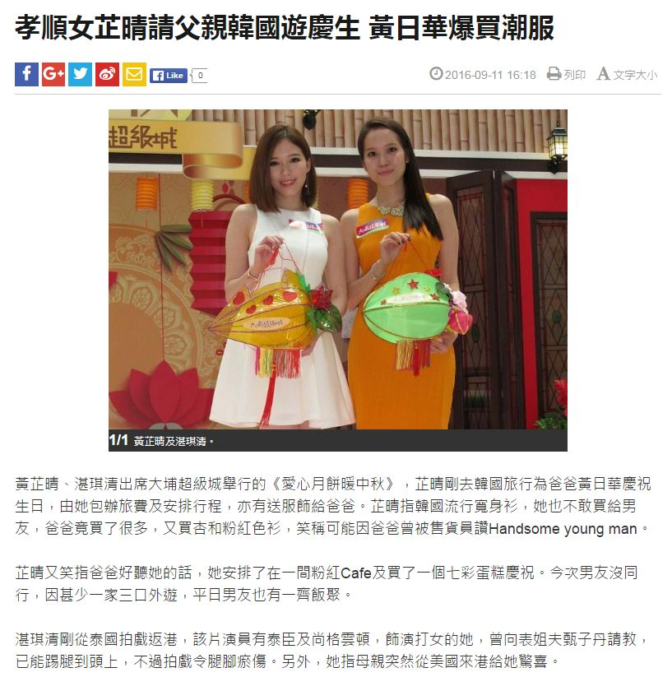

Hong Kong 01
11 Sep, 2016
http://www.hk01.com/%E6%B8%AF%E8%81%9E/42488/80%E5%91%8E%E5%B7%A8%E5%9E%8B%E6%9C%88%E9%A4%85-%E9%80%81%E8%B4%88200%E4%BD%8E%E6%94%B6%E5%85%A5%E5%AE%B6%E5%BA%AD%E9%BD%8A%E6%85%B6%E4%BD%B3%E7%AF%80
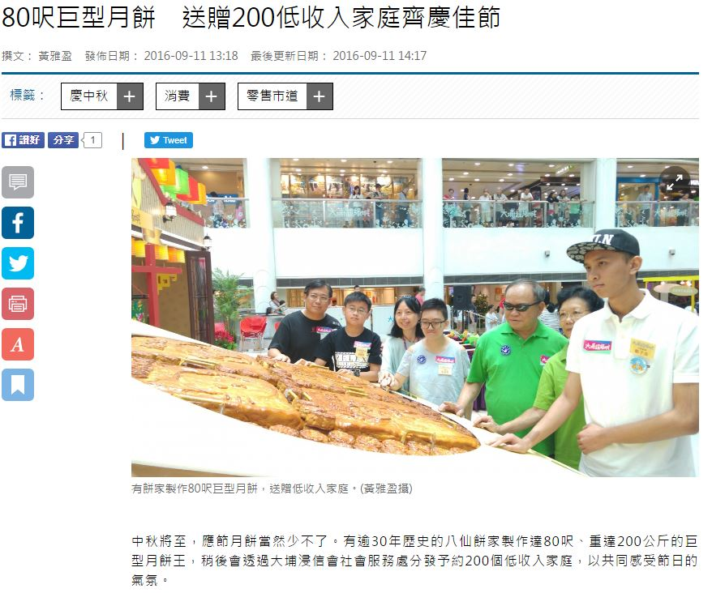
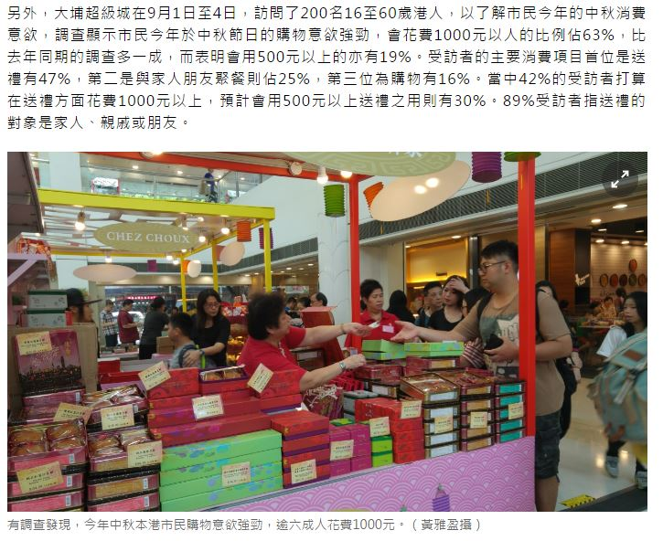

On cc
11 Sep, 2016
http://hk.on.cc/hk/bkn/cnt/entertainment/20160911/bkn-20160911142255071-0911_00862_001.html
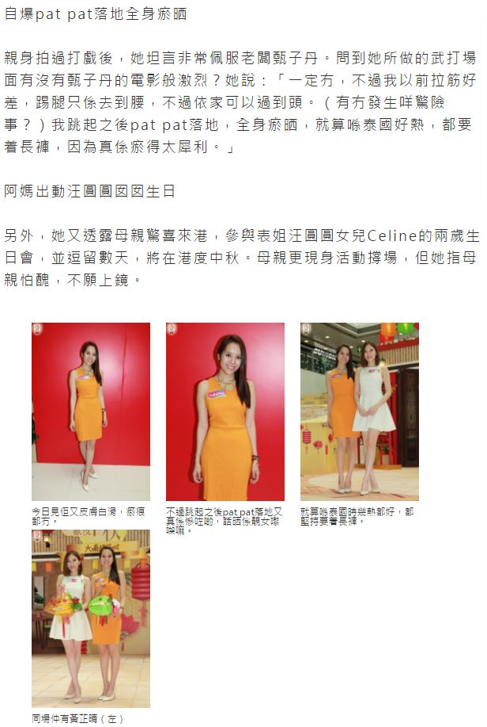
On cc
11 Sep, 2016
http://hk.on.cc/hk/bkn/cnt/entertainment/20160911/bkn-20160911135133728-0911_00862_001.html
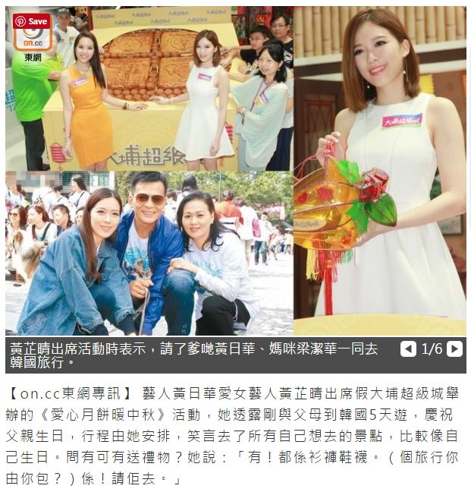

Yahoo! Via Sing Tao
11 Sep, 2016
https://hk.news.yahoo.com/%E5%AD%9D%E9%A0%86%E5%A5%B3%E8%8A%B7%E6%99%B4%E8%AB%8B%E7%88%B6%E8%A6%AA%E9%9F%93%E5%9C%8B%E9%81%8A%E6%85%B6%E7%94%9F-%E9%BB%83%E6%97%A5%E8%8F%AF%E7%88%86%E8%B2%B7%E6%BD%AE%E6%9C%8D-082000243.html
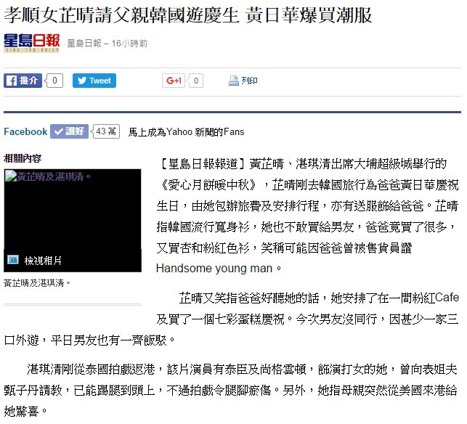

Sing Tao
12 Sep, 2016
http://std.stheadline.com/daily/news-content.php?id=1475571&target=2
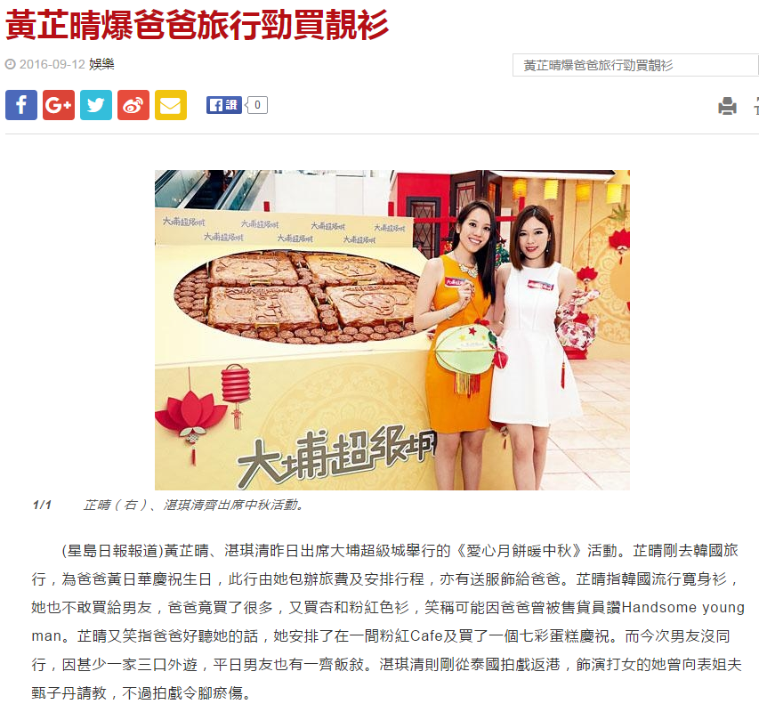

Yahoo! Via Sing Tao
12 Sep, 2016
https://hk.celebrity.yahoo.com/%E9%BB%83%E8%8A%B7%E6%99%B4%E7%88%86%E7%88%B8%E7%88%B8%E5%8B%81%E8%B2%B7%E9%9D%9A%E8%A1%AB-222018901.html
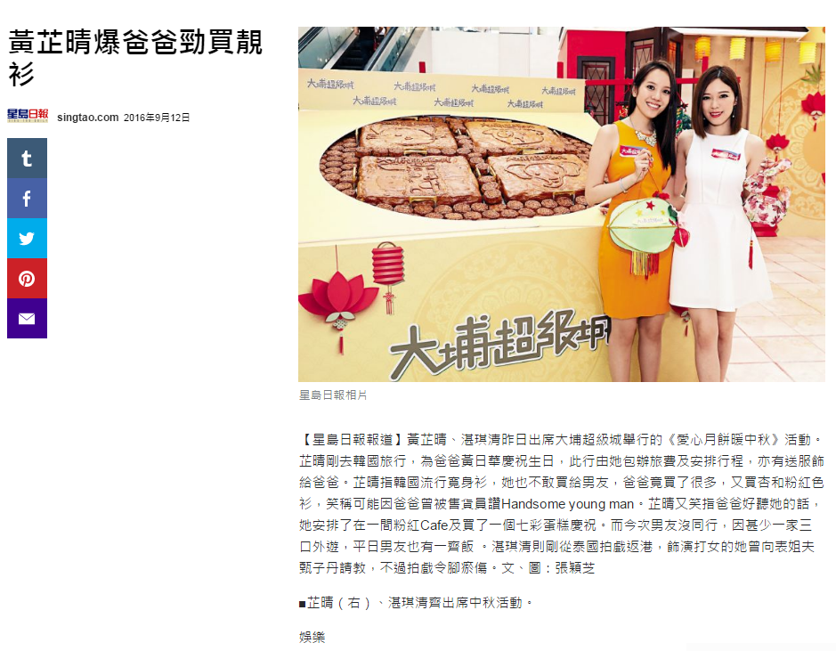

Apple Daily
12 Sep, 2016
http://hk.apple.nextmedia.com/entertainment/art/20160912/19767833
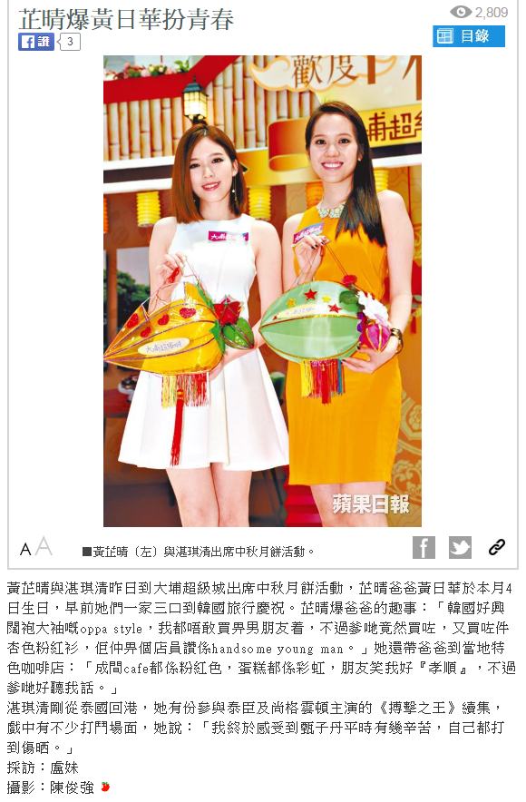

Oriental Daily
12 Sep, 2016
http://orientaldaily.on.cc/cnt/entertainment/20160912/00282_062.html

