Date: 29 July 2016
Time: 12:00pm
Venue: Zone C, Tai Po Mega Mall

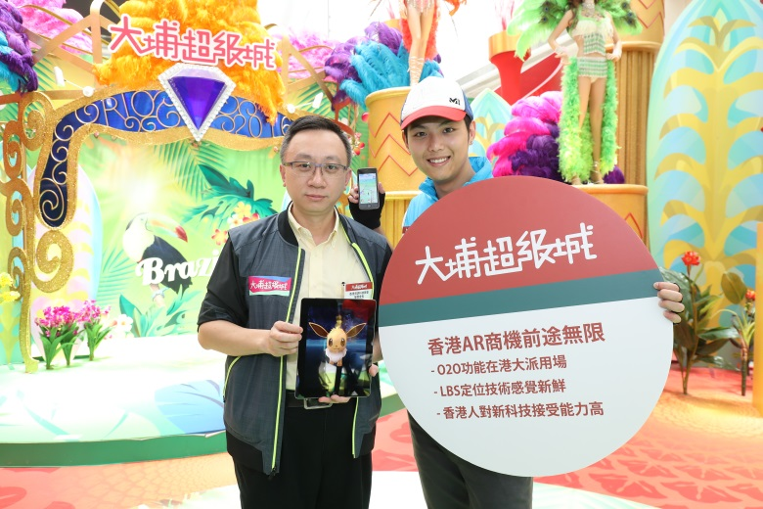
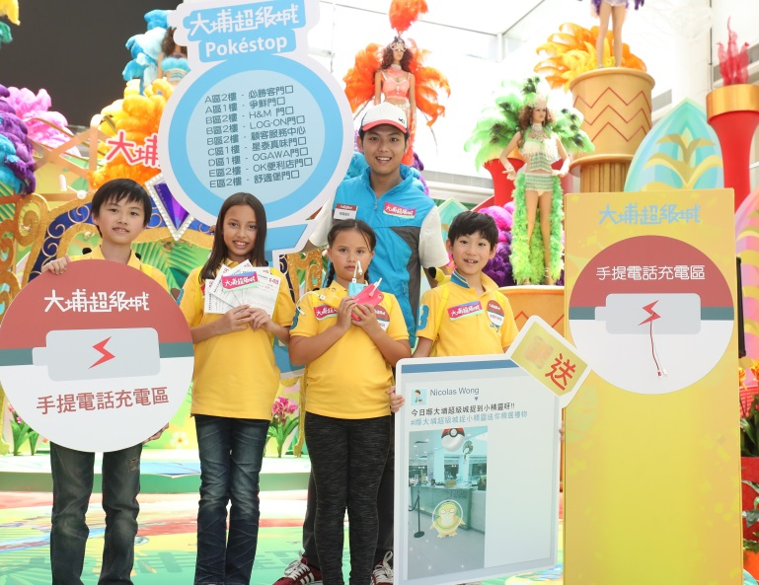

Headline
P.13 – 1/4
30 Jul, 2016
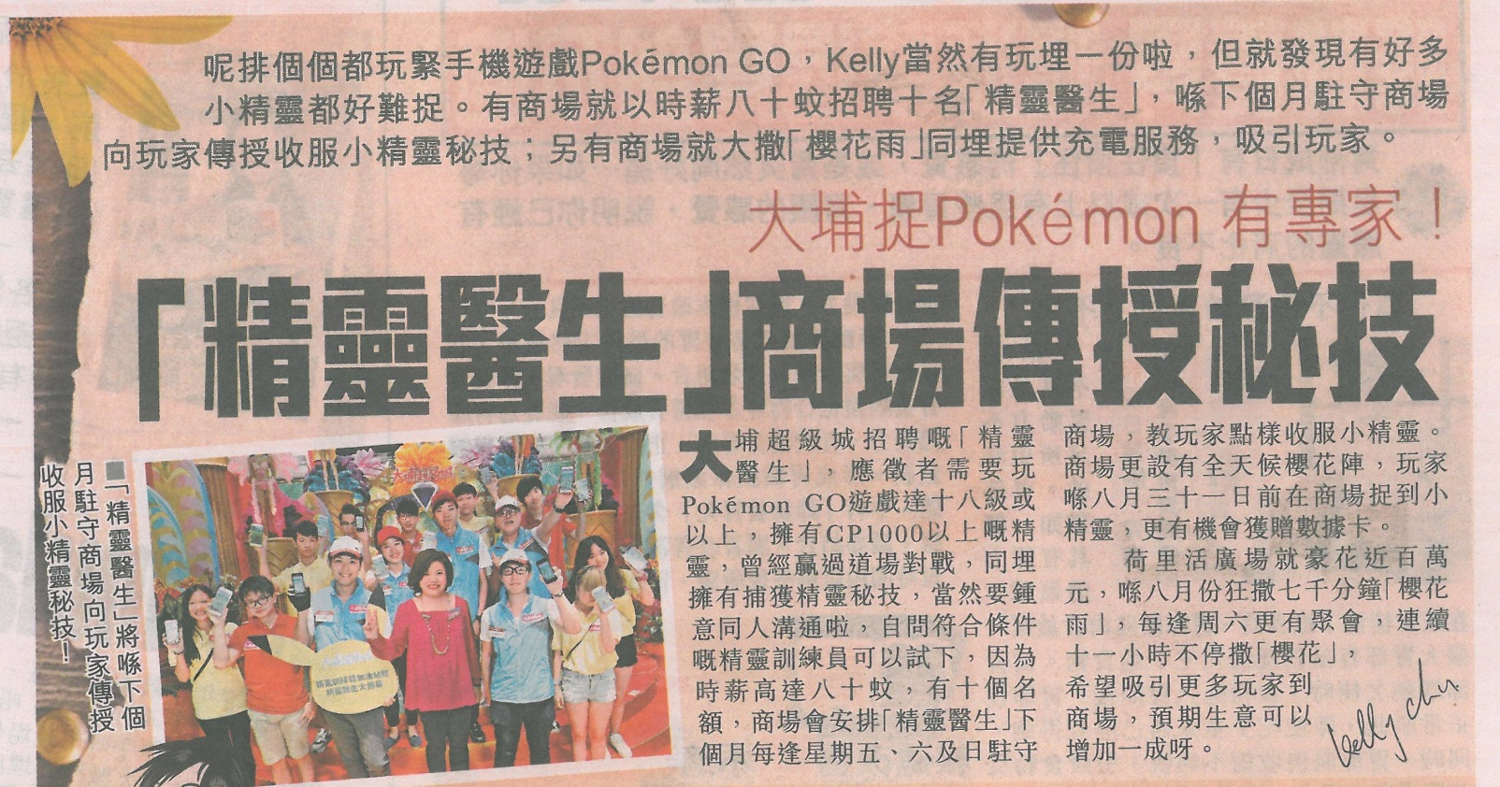

Wen Wei Po
A11 – 1/3
30 Jul, 2016
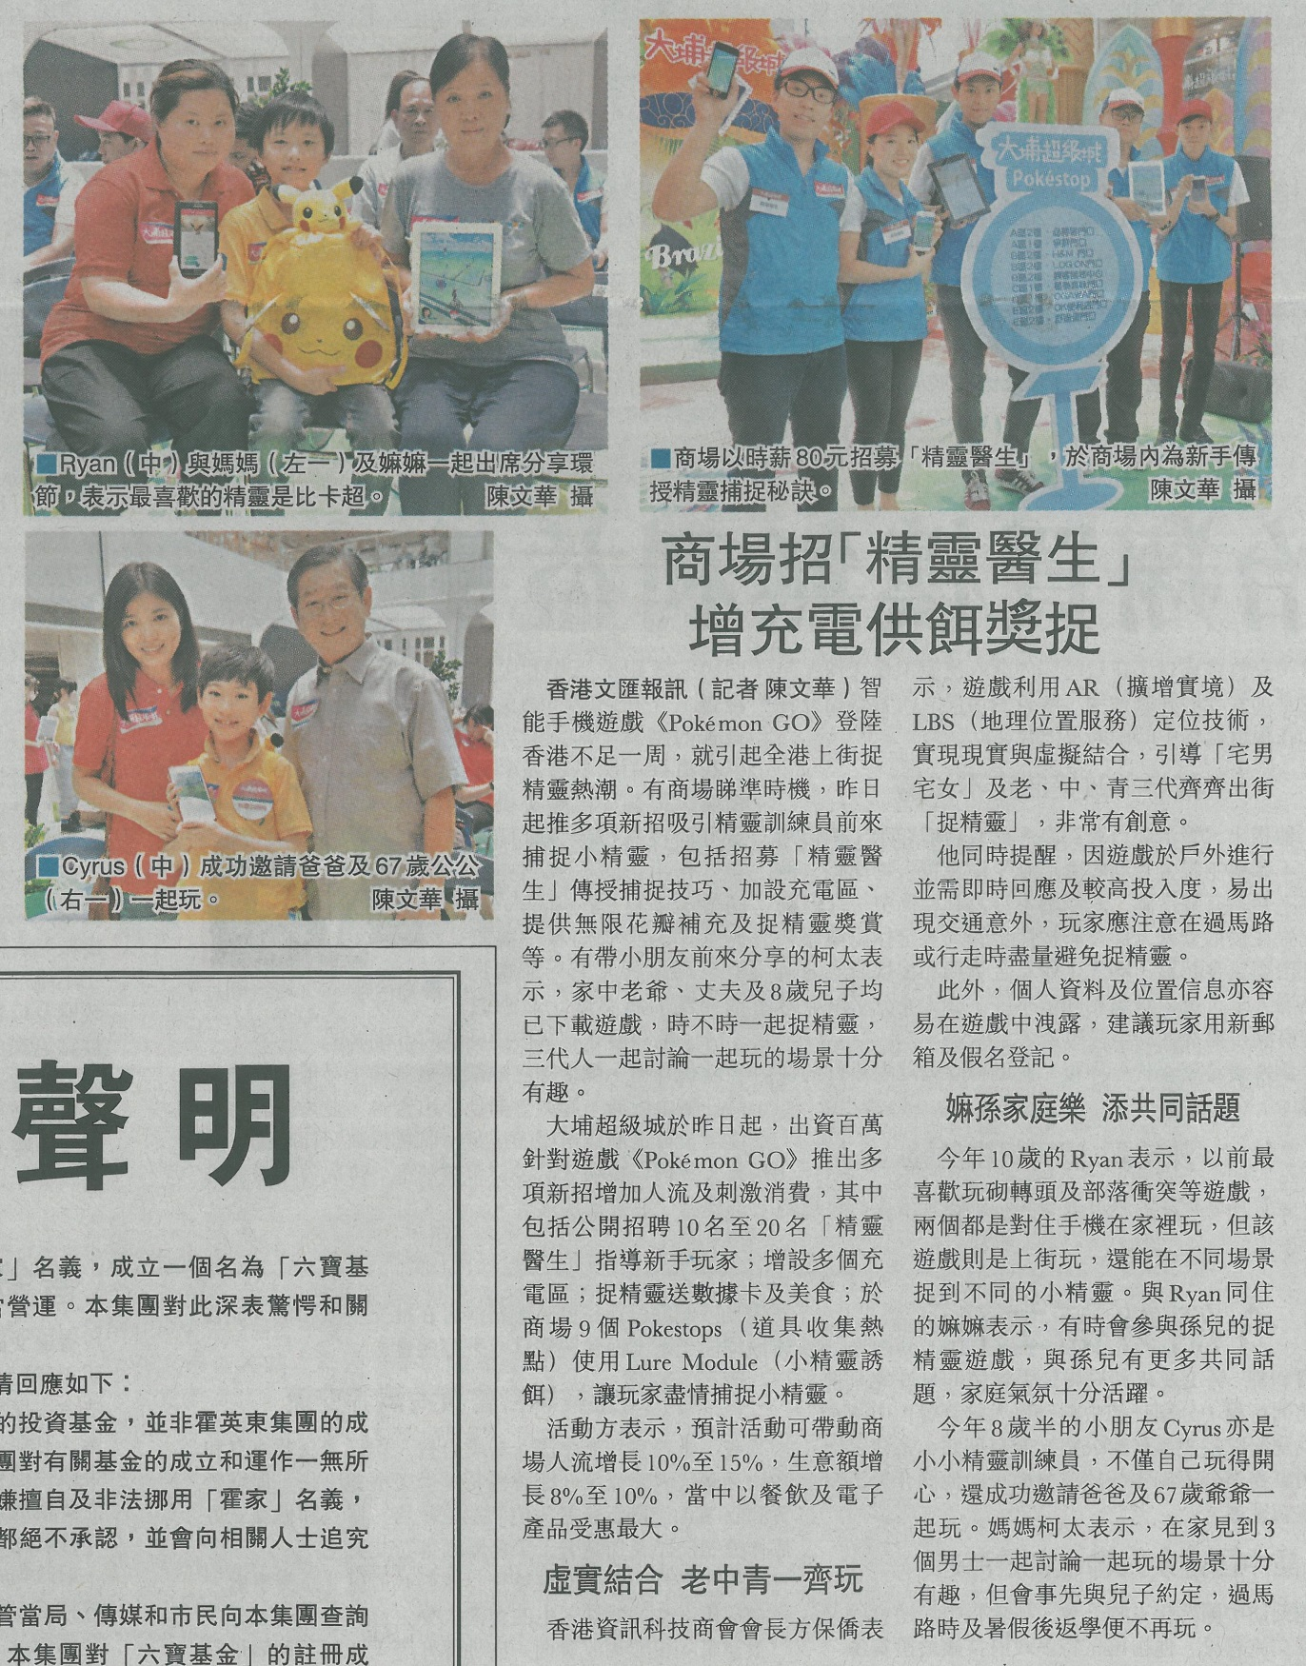

Hong Kong Economic Times
29 Jul, 2016
http://topick.hket.com/article/1473185/Pok%C3%A9mon%20GO%E4%B8%89%E4%BB%A3%E9%BD%8A%E7%8E%A9%20%E6%AF%8D%E5%80%9F%E6%A9%9F%E6%9C%83%E6%95%99%E4%BB%94
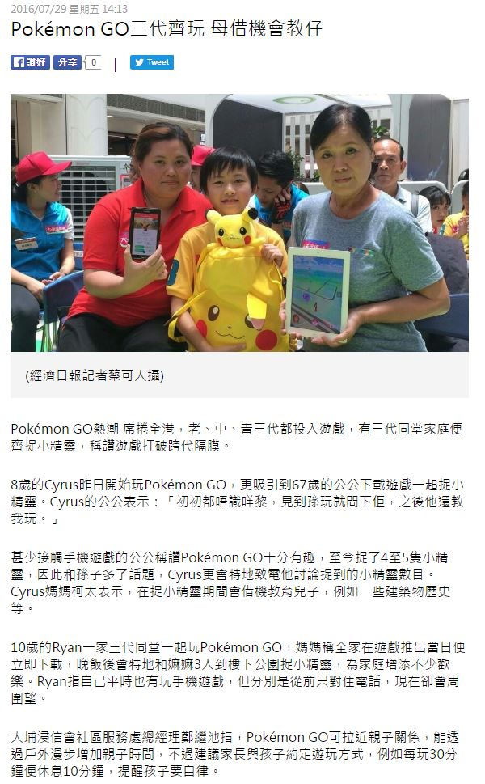

Nakuz.com Forum
29 Jul, 2016
http://www.nakuz.com/thread-4534536-1-1.html
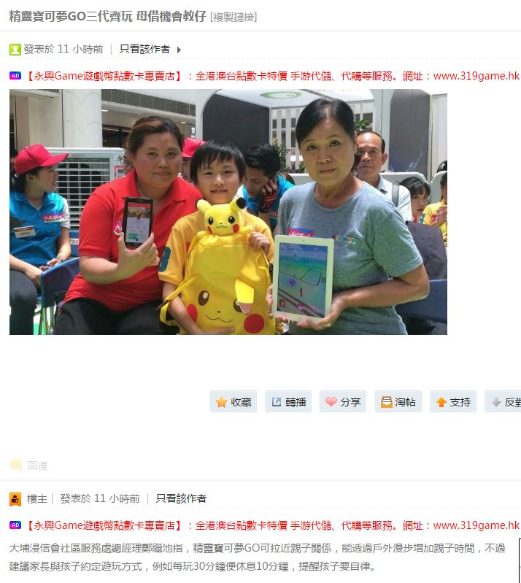

Headline
30 July, 2016
http://hd.stheadline.com/news/columns/0/20160730/478347/
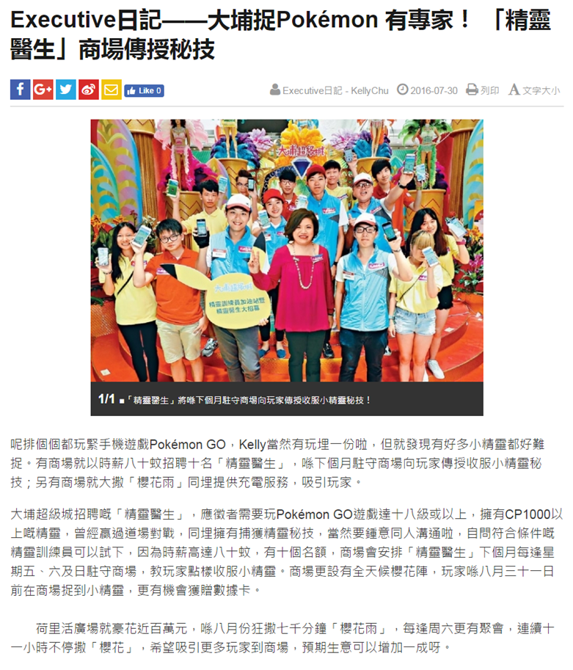

Headline – Kelly Chu’s Blog
30 July, 2016
http://blogcity.me/blog/reply_blog_express.asp?f=DGM8WHZ94I120821&id=829759&tm=36110.91

Wen Wei Po
30 July, 2016
http://pdf.wenweipo.com/2016/07/30/a11-0730.pdf
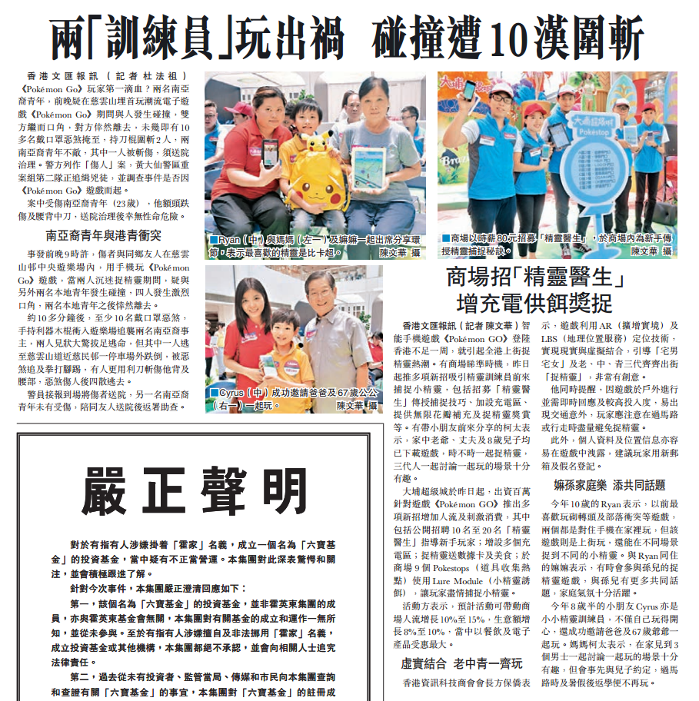

方保僑 Francis Fong – Facebook
30 Jul, 2016
https://www.facebook.com/francisfongpokiu/photos/a.1060620870624833.1073741827.290023217684606/1189064864447099/?type=3&theater
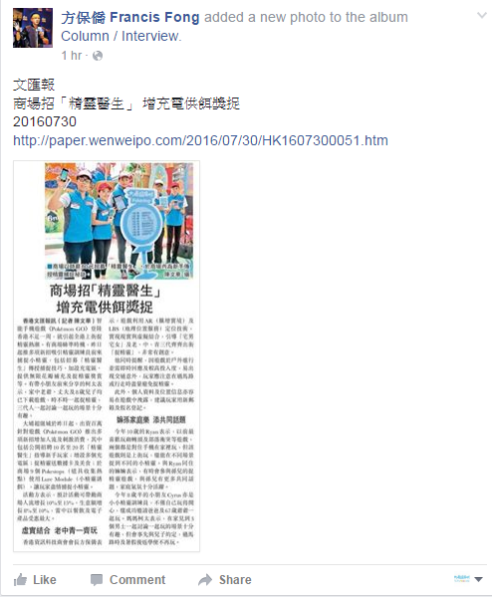

方保僑 Francis Fong – Facebook
30 Jul, 2016
https://www.facebook.com/francisfongpokiu/posts/1189021464451439
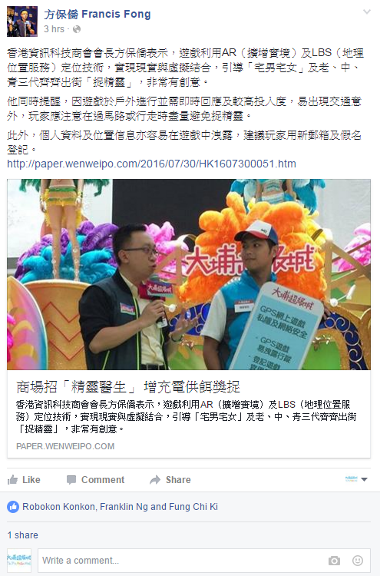

Headline POP News – Facebook
30 Jul, 2016
https://www.facebook.com/headlinepopnews/photos/a.663194820375086.1073741826.661418780552690/1331882506839644/?type=3&theater
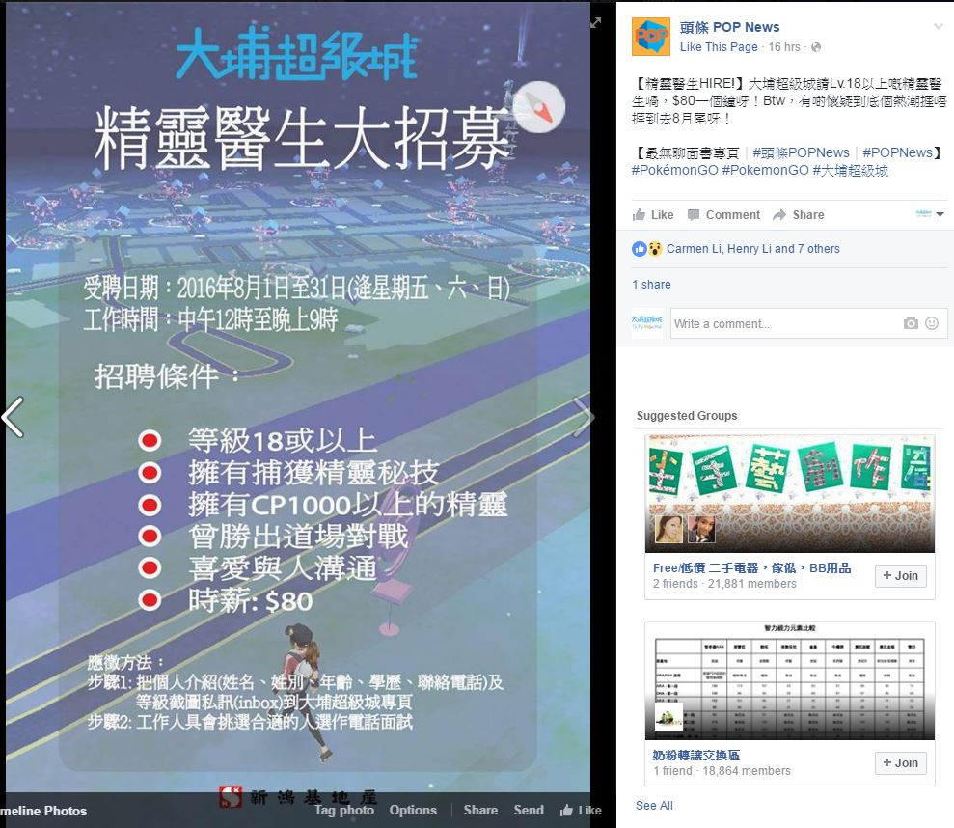

Phoenix TV – IFENG.COM
30 Jul, 2016
http://v.ifeng.com/news/society/201607/01a82666-681d-474d-9108-fc9154a60ccb.shtml

